**UML Diagrams**

UML stands for Unified Modeling Language. It’s a rich language to model software solutions, application structures, system behavior and business processes. There are two main categories; structure diagrams and behavioral diagrams.

Structure diagrams include:

* Class Diagram

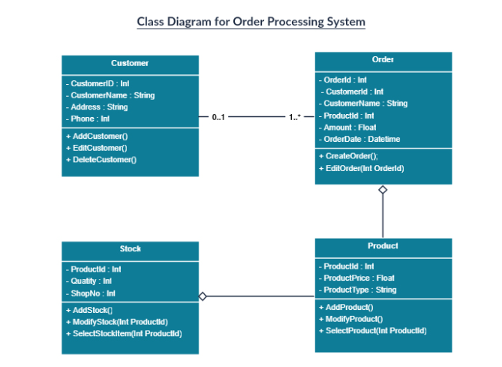

* Component Diagram

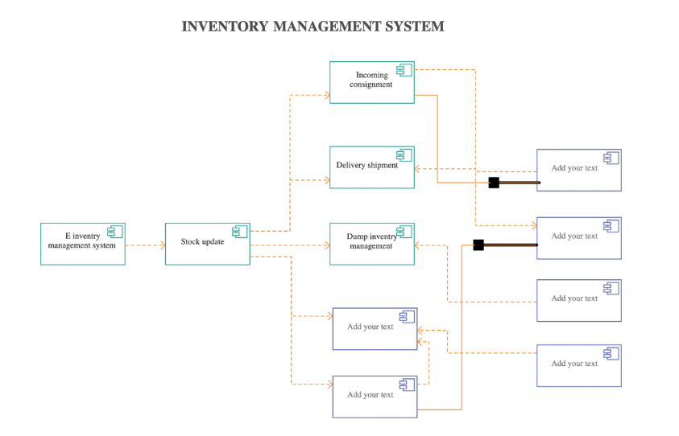

* Object Diagram

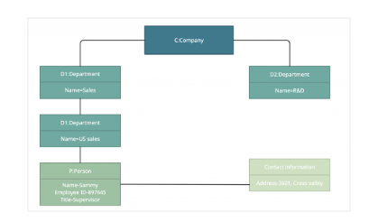

* Composite Structure Diagram

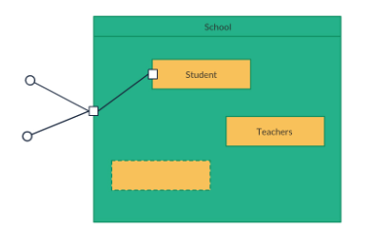

Behavioral diagrams include:

* Use Case Diagram

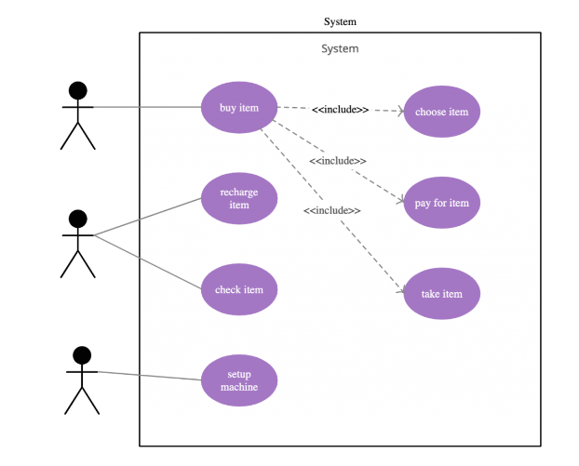

* Activity Diagram

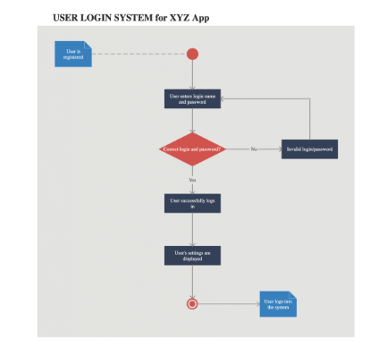

* Sequence Diagram

